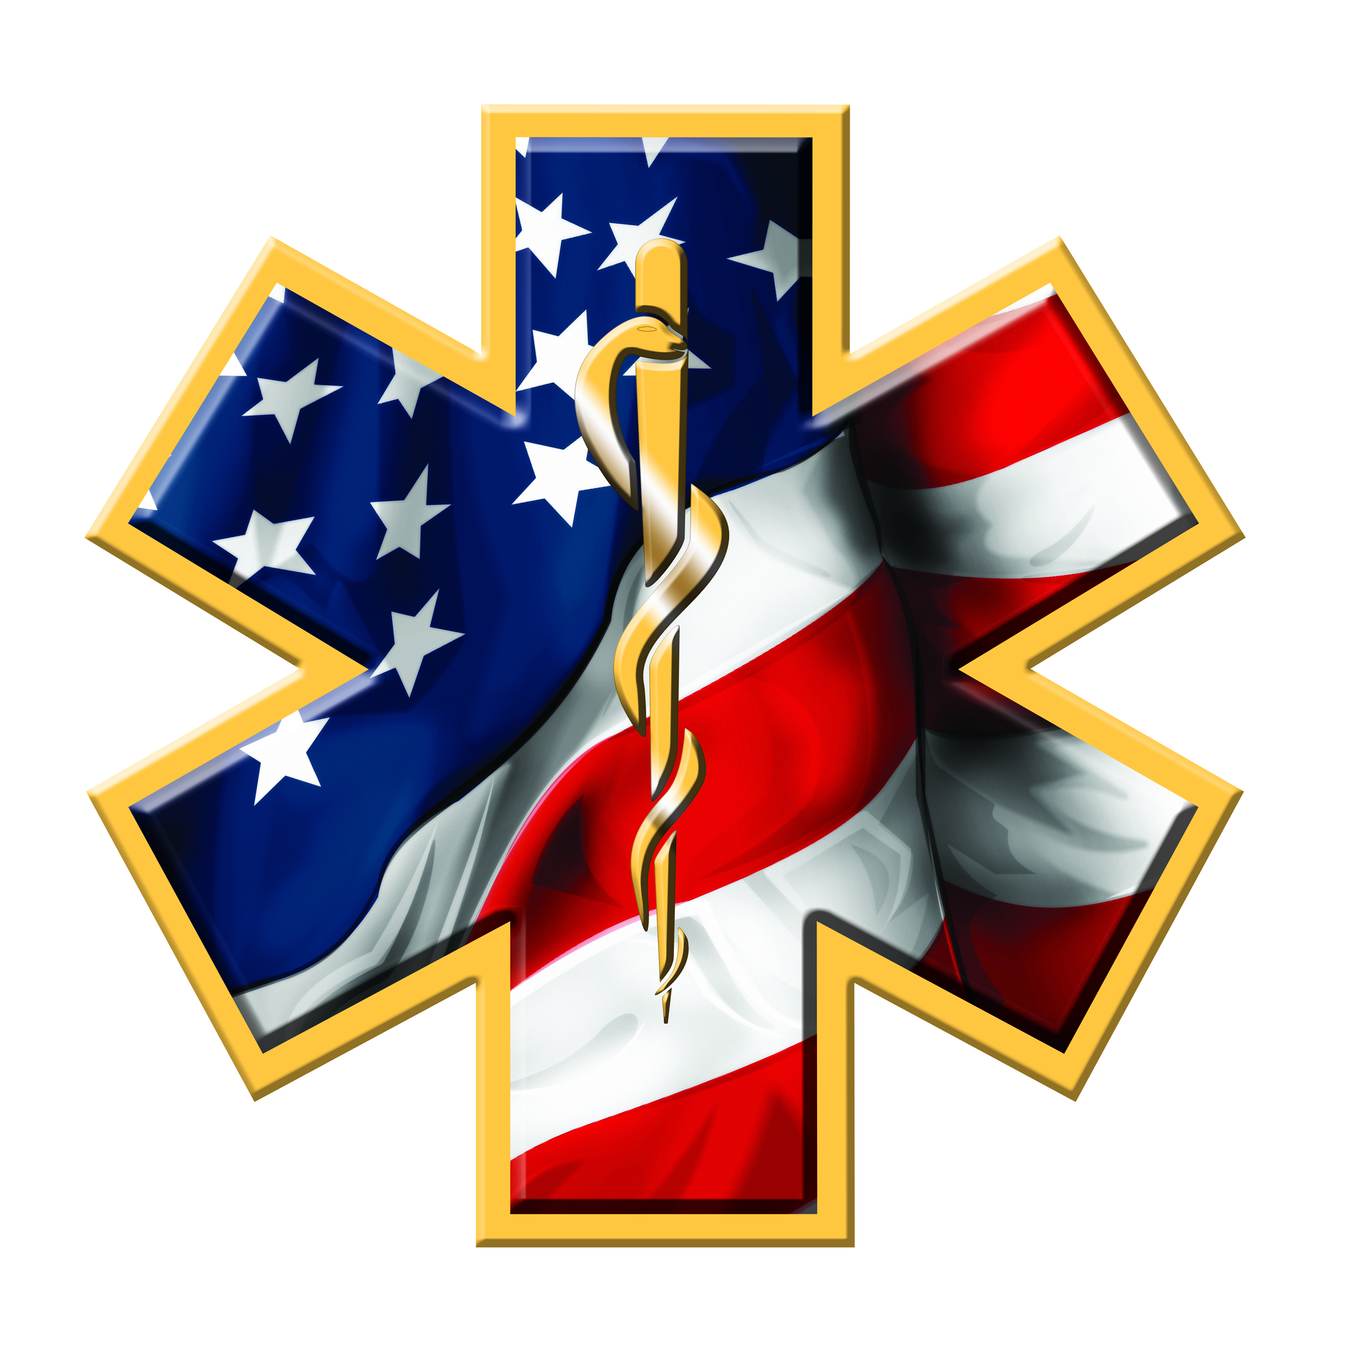

Marion County Ambulance District

142 Jaycee Drive

Hannibal, Missouri 63401

Phone (573)221-5510 Fax (573)221-5004

July 11, 2023, 12:30 P.M.

Notice is hereby given that Marion County Ambulance District will conduct a board meeting at 6:00 p.m. on Wednesday, July 12, 2023, at the Administration Building located at 142 Jaycee Drive, Hannibal, Missouri.

The tentative agenda of this meeting includes:

1. Call to order
2. Approval of minutes of regular meeting held on May 18, 2023.
3. Review reports for May and June 2023.
4. Chief’s Report
5. Old Business
6. Tuition Policy
7. New Business
8. Audit Report
9. Adjourn

Representatives of the news media may obtain copies of this notice by contacting:

John Nemes

142 Jaycee Drive

Hannibal, MO 63401

573-221-5510