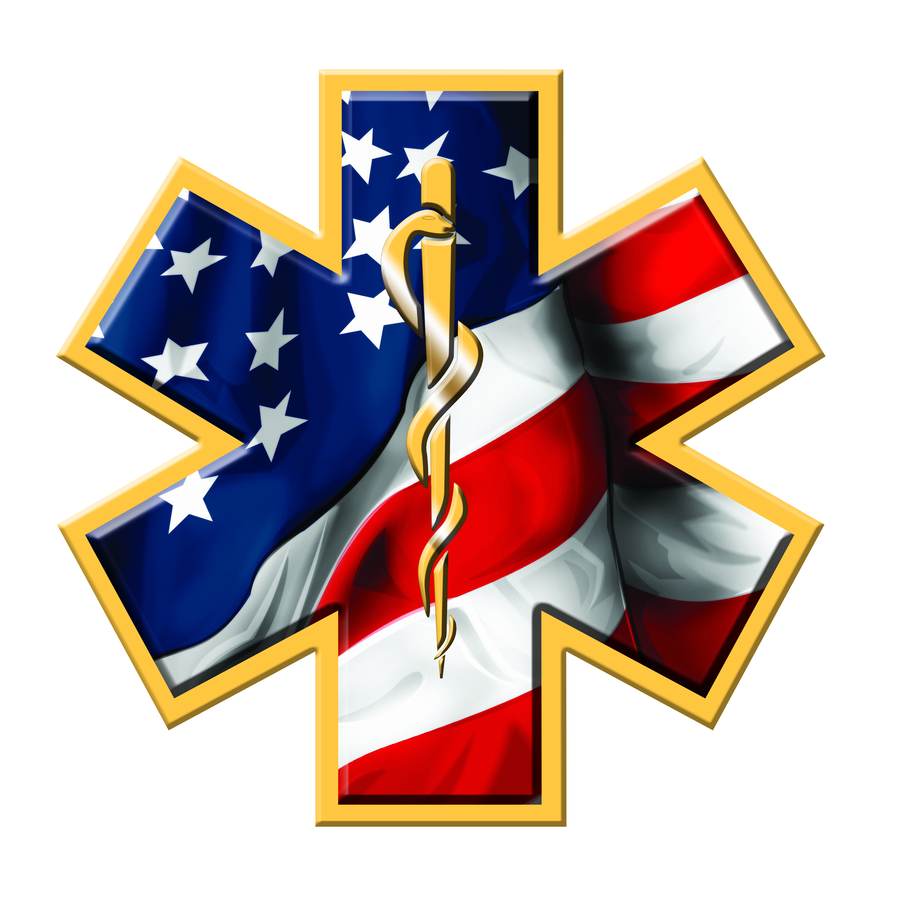

Marion County Ambulance District

142 Jaycee Drive

Hannibal, Missouri 63401

Phone (573)221-5510 Fax (573)221-5004

September 5th, 2024, 5:30 P.M.

Notice is hereby given that Marion County Ambulance District will conduct a board meeting at 6:00 p.m. on Friday, September 6th , 2024, via Zoom at <https://us02web.zoom.us/j/86926718566?pwd=j6alzzkp8gAEl3n91jYl81aQELBrJM.1>

The tentative agenda of this meeting includes a vote to close part of this meeting pursuant to RSMo Section 610.021.2 for discussion of leasing, purchase or sale of real estate:

1. Call to order
2. New Business
3. Vote to close public session
4. Vote to re-open public session
5. Adjourn

Representatives of the news media may obtain copies of this notice by contacting:

John Nemes

142 Jaycee Drive

Hannibal, MO 63401

573-221-5510